Identify_positions.py:

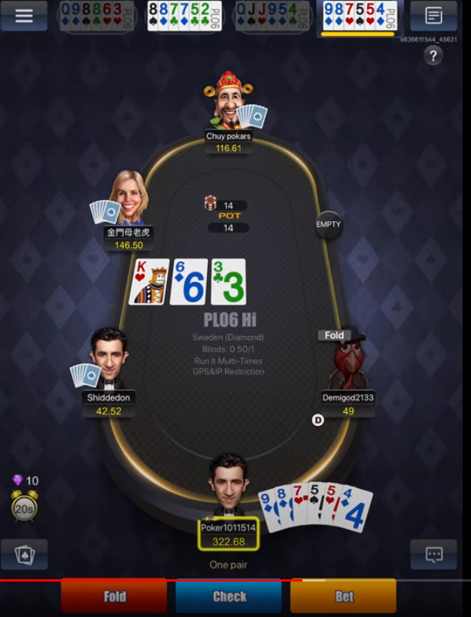
- fill_opponents_in_pot() - dict. The dictionary will have 6 keys- 1 to 6 and we want to fill each with True or False (boolean) based on if the player is still in the pot; if they are greyed out, it means they are no longer in the pot.
This function will run just when it is my turn to play. It is my turn to play when the times starts running down, as you can see in the screenshot- the yellow bar at the top right, or going in a rectangle around my character.
If there is no one sitting in the seat- like in position 5 in the screenshot, fill it with False.

- my_relative_position() - fill self.my_position with my position relative to the button (the dark D with a circle around it).
So in the screenshot I would be in position 1, because I am directly to the left of button.
If I was one more to the left, I would be position 2.

mixxin_action_behind_me.py

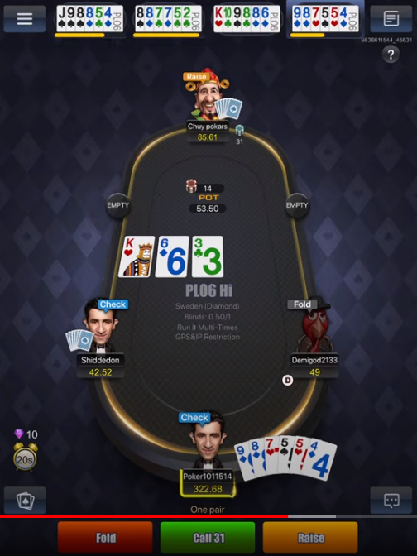
- def opponents_bet_behind_me(self);
need to fill a dictionary with 6 keys;
to state the value of what the person is betting, so in the screenshot, we would have:
self.opp_bet_behind = {}
self.opp_vet_behind = {1:0, 2:0, 3:0, 4:31, 5:0, 6:0}

PRE_FLOP POST_FLOP
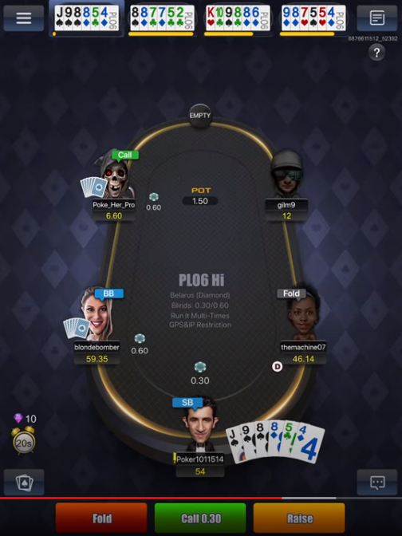
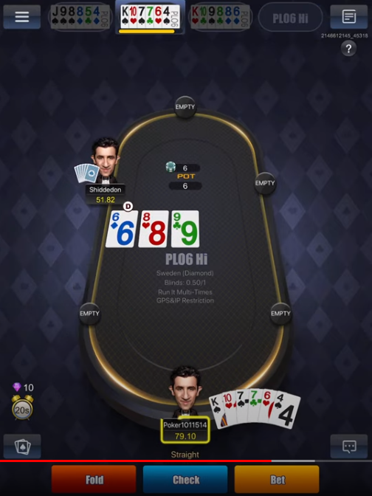

VS.

mixin_action_behind_me.py

- At the end of the script, I need to set self.still_pre_flop to False if we are no longer pre_flop and we determine this by scannign the middle of the pot as shown in the screenshot; in the left we are still pre_flop (do nothing), but in the righ we are no longer pre_flop (set self.still_pre_flop=False)

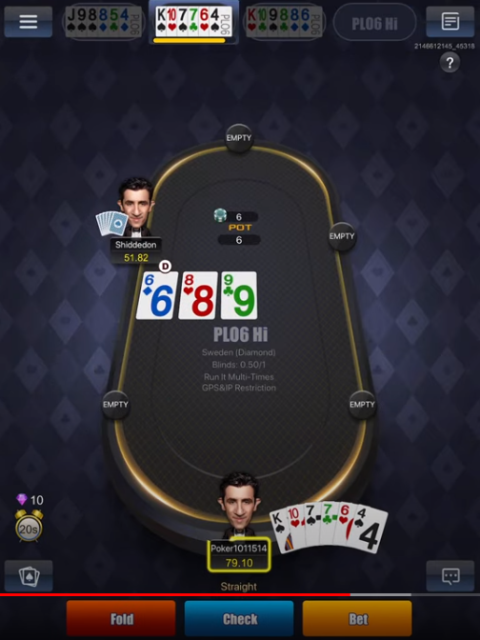
- plo6_pre_flop_play_logic.py

- Scan my hand (middle bottom of screen), and fill in self.nums_list = [] and self.suit_list = []

so in the example in the screenshot we would have:

self.nums_list = [13,10,7,7,6,4]
self.suit_list = [‘s’, ‘h’, ‘s’, ‘c’, ‘h’, ‘s’]

The suit colour will always be the same:
- Spade = Black
- Clubs = Green
- Heart = Red
- Diamonds = Blue

The numbers will run from 2 – 14, and it will always be in descending order.

